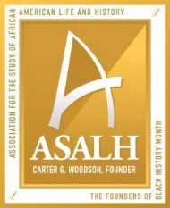
2020 National Underground Railroad Network to Freedom Grants

Certification of Matching Share

As the authorizing official, I certify that the matching share funds identified above are available, and that they will be allocated only to the 2020 NTF Grant project described in this application:

____________________________________________________________________________
(Project Title)
____________________________________________________________________________
(NTF Listing Name)

________________________________________ ___________________________________
(Authorizing Official Name) (Title)

____________________________________________ _________________________
(Signature) (Date)

The Match Certification Form must be signed by a person legally authorized to commit the funds to the grant project. In-kind matches are not eligible. Applicants must also submit appropriate documentation of the matching share (copies of bank statements, etc.). Please make sure to black out any account numbers or personally sensitive information contained in financial documentation that is submitted.
Please note that applications without documentation MAY NOT receive full credit for the matching share. Match must be “in-hand” by May 29, 2020.

