Dear HBCU Affiliates,

Join the virtual book discussion by author, Dr. Jelani Favors as he shares his book Shelter in a Time of Storm: A live question and answer discussion with the author will be on June 10th at 6:00PM. The Yamacraw-Savannah Branch of ASLAH (Association of African American History and Literature) asks that you share this invitation with all of your HBCU family of students, faculty, staff, and alums.
The Telfair Museums of Savannah will host this event and free pre-registration is required.
REGISTER TODAY https://www.telfair.org/los
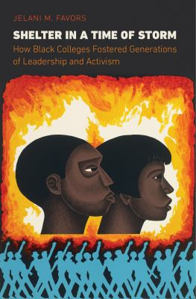 A trailer of this book can be viewed at https://www.youtube.com/watch?v=trMOIu_7UuE

June 10, 2021 – Jelani Favors – Shelter in a Time of Storm: How Black Colleges Fostered Generations of Leadership and Activism, University of North Carolina Press, 2019.
Join us on June 10 at 6PM for a discussion of Shelter in a Time of Storm: How Black Colleges Fostered Generations of Leadership and Activism with author Jelani M. Favors. Favors, an assistant professor of history at Clayton University, will present his book on the development and significance of historically Black colleges and universities, highlighting the ways in which they played pivotal roles during the Jim Crow era and the civil rights and Black Power movements. This virtual book club is free and open to the public. A live Q&A will follow a brief presentation.
REGISTER NOW
Books maybe available in your local libraries and favorite book stores.
Sincerely

Lemuel Patterson, Vice President
Yamacraw-Savannah Branch

